Experiment No. 3
Aim: Develop a menu-driven program for Circular Queue using Array.
Tools:
- Programming Language: C
- IDE: Visual Studio Code
Theory:
A Circular Queue is a linear data structure that follows the FIFO (First In, First Out) principle. Unlike a linear queue, the last position of the queue is connected to the first position, forming a circular structure. This allows efficient utilization of memory by reusing the empty spaces created after deletion.
The queue uses two pointers:
Front – points to the first element.
Rear – points to the last element.
When the rear reaches the last index of the array, it wraps around to the beginning using the modulo (%) operator. This avoids the problem of unused spaces in a linear queue.
The basic operations are:
- Enqueue: Insert an element.
- Dequeue: Remove an element.
- Display: Show all elements of the queue.
Algorithm for Enqueue
- Start.
- Check if the queue is full.
- If full, display "Queue Overflow".
- Otherwise:
  - If the queue is empty, set front = rear = 0.
  - Else, update rear = (rear + 1) % MAX.
  - Insert the new element at queue[rear].
- Stop.
Algorithm for Dequeue
- Start.
- Check if the queue is empty.
- If empty, display "Queue Underflow".
- Otherwise:
  - Store the element at front.
  - If front == rear, set front = rear = -1.
  - Else, update front = (front + 1) % MAX.
- Display the deleted element.
- Stop.
Algorithm for Display
- Start.
- Check if the queue is empty.
- If empty, display "Queue is Empty".
- Otherwise:
  - Start from front.
  - Print each element.
  - Continue until rear is reached using circular indexing.
- Stop.
Program:
#include <stdio.h>
#define N 5
int rear = -1;
int front =-1;
int array[N];
void equeue(){
int num;
printf("Enter the number you want to add: ");
scanf("%d",&num);
if((rear+1)%N==front){
printf("Overflow");
}
else if(front==-1 && rear==-1){

front=rear=0;
array[rear]=num;
}else{
rear=(rear+1)%N;
array[rear]= num;

}
}
void dequeue(){
if(rear==-1&&front==-1){
printf("Underflow\n");
}else if(rear==front){
printf("%d deleted\n",array[front]);
rear=front=-1;
}else{
printf("%d deleted\n",array[front]);
front= (front+1)%N;

}
}
void peek(){
printf("THe top most element is: %d",array[front]);
}
void display(){
for(int x=0;x<=N-1;x++){
printf("%d\n",array[x]);
}
}
int main() {
// Write C code here
int loop =0;
do{
int choice;
printf("1- Enqueue \n2- Dequeue\n3-Peek\n4-Display\n5-Exit\nEnter your choice: ");
scanf("%d",&choice);
switch (choice){
case 1: equeue();
break;
case 2: dequeue();
break;
case 3: peek();break;
case 4: display();break;
case 5: printf("Exiting..");loop=1;break;
}}while(loop==0);

return 0;
}
Output:
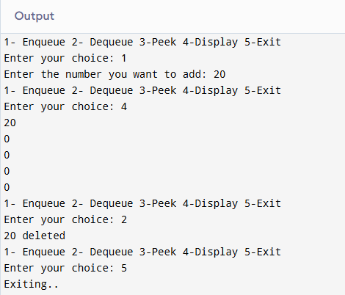
Learning Outcome:
LO3.1 Implement Queue operations.
LO3.2 Analyze overflow and underflow conditions.

Course Outcome:
After completion of the course the learner should be able to:
CO1: Differentiate linear and non-linear data structures based on their organization, operations, and computational efficiency.
CO2: Demonstrate the use of stacks and queues to solve real-world computational problems.
CO3: Implement and analyse linked list structures and their operations for dynamic data management.
CO4: Make use of tree structures for hierarchical data representation and efficient searching.
CO5: Examine real-world problems using graph data structures and associated techniques.
CO6: Evaluate advanced data structures based on performance characteristics and application requirements.

Conclusion:
________________________________________________________________________________
________________________________________________________________________________
________________________________________________________________________________
________________________________________________________________________________

Viva Questions:
________________________________________________________________________________
________________________________________________________________________________
________________________________________________________________________________
________________________________________________________________________________
For Faculty Use
Correction Parameters | Formative Assessment [40%] | Timely completion of Practical [40%] | Attendance / Learning Attitude [20%]
Marks Obtained

